Readme for WEDE5020 assignment part 2
ST10497679 Nkosi Biko
Upload files · Nkspark16/ST10497679-Assignment-part-2
Perfect Plumbing is here to provide honest work and quality service at an affordable prices to put your wallets at ease.
We aim to provide professional, reliable and cost-effective solutions while keeping a high standard of workmanship, safety, cleanliness and great customer service.
We understand that quality plumbing is important to the smooth operation and value at any residential, commercial or industrial property and Our team strives to deliver and are committed to completing every project efficiently with little to no problem.
Clear communication Attention to detail Respect for clients' property Efficient project completion After-service support
Our goal is not simply to repair or install plumbing, but to provide a cheaper dependable solution that gives the client confidence in the completed work and relief for their wallets.
Perfect Plumbing will take reasonable measures to maintain a safe working environment throughout the project.
Our team will take care to protect the client's property and keep work areas as clean and organized as reasonably possible.
Any hazardous conditions identified during the work will be brought to the client's attention.
If additional plumbing problems are discovered after work has commenced, Perfect Plumbing will notify the client and provide an additional quotation where practical.
No significant additional work will be undertaken without the client's approval, except where immediate action is reasonably necessary to prevent further damage or risk. Perfect Plumbing will stand behind the quality of its workmanship in accordance with the agreed quotation and applicable terms. Manufacturer warranties on supplied products or equipment will remain subject to the individual manufacturer's warranty conditions. We appreciate the opportunity to provide this proposal and look forward to working with you.
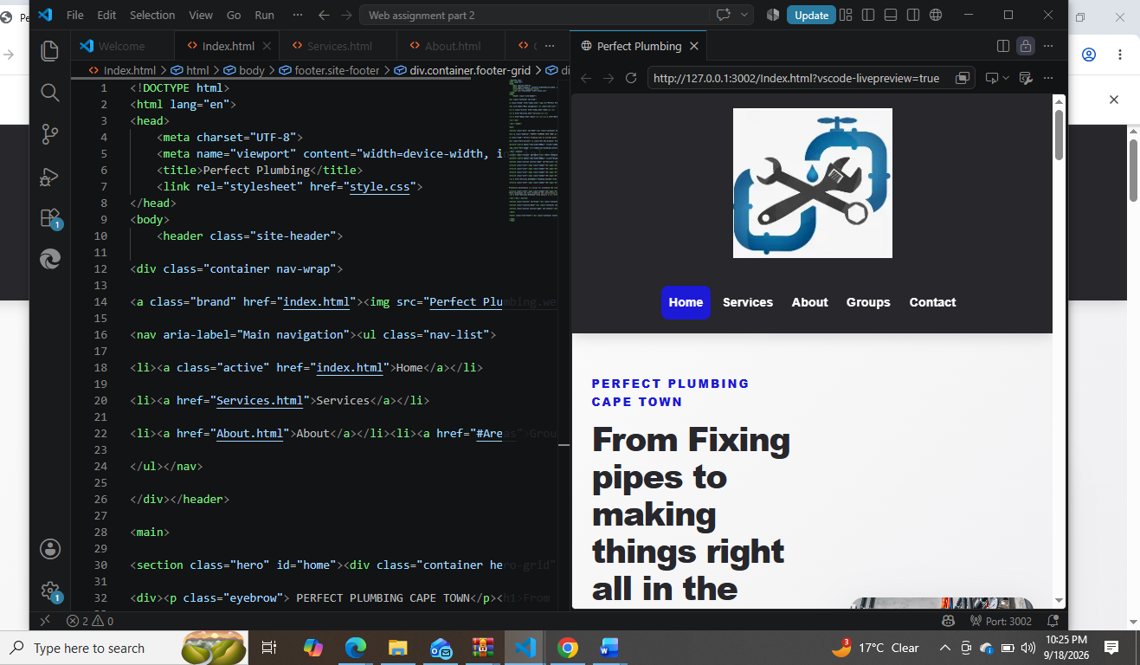
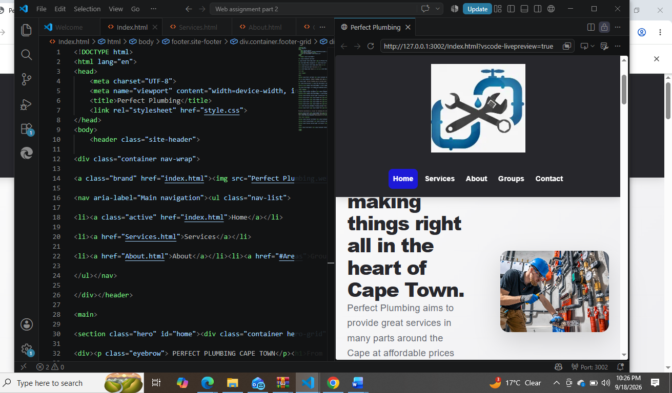
Took some notes from the prac and copied some things from scratch and tested things out and ended up with something I liked.
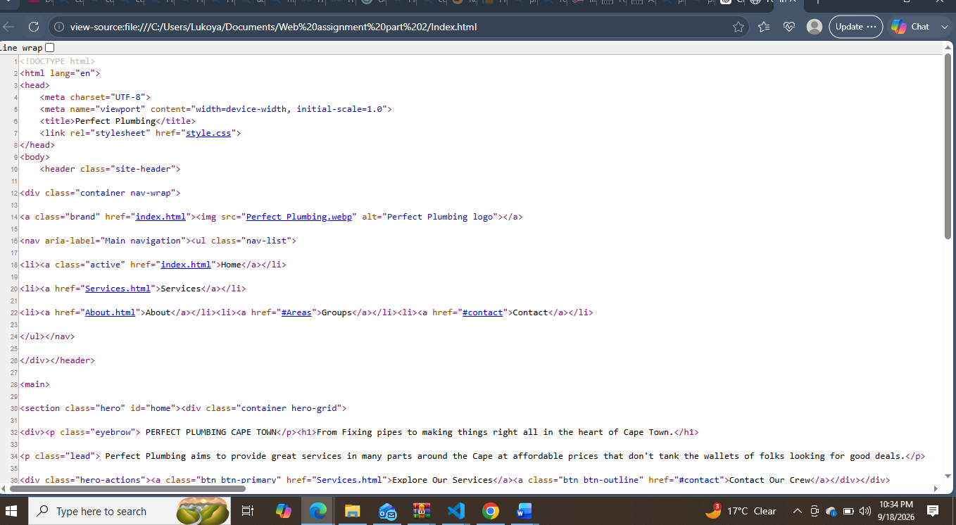
This is the website’s code it’s looks a little bit better in dark mode.
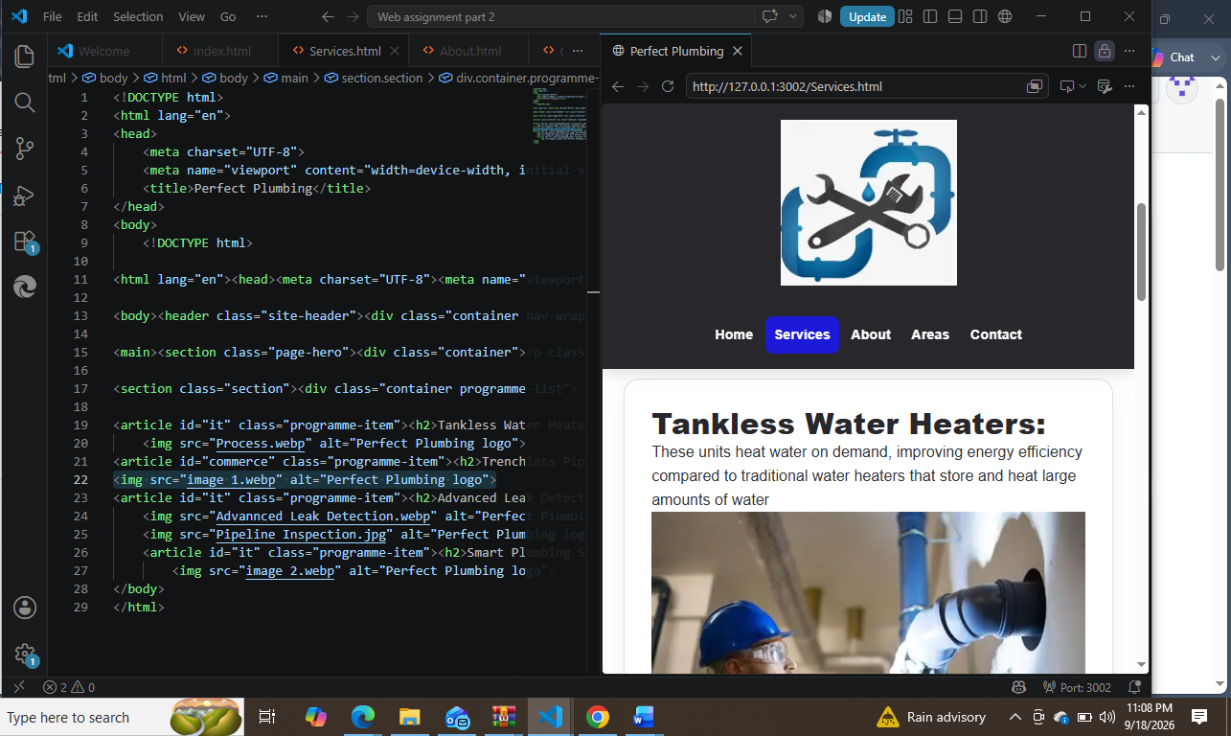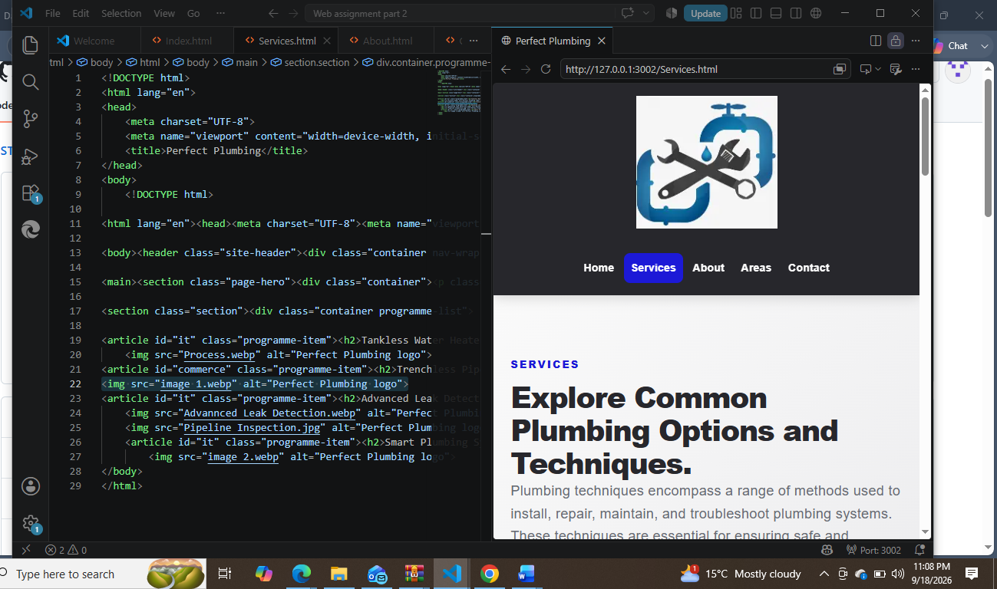
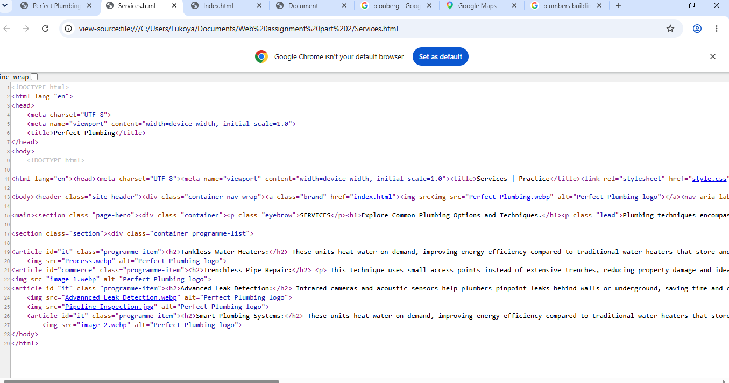
The pictures on top took longer to figure out I wasn’t happy with the first few results but after some trial and error I finally got the thing looking the way I wanted it to.
The last picture is the result.
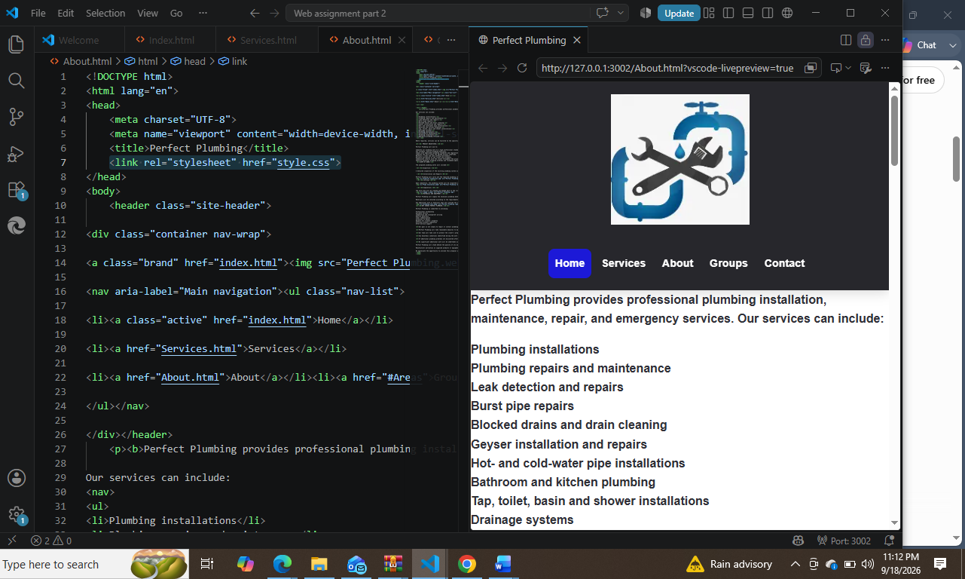
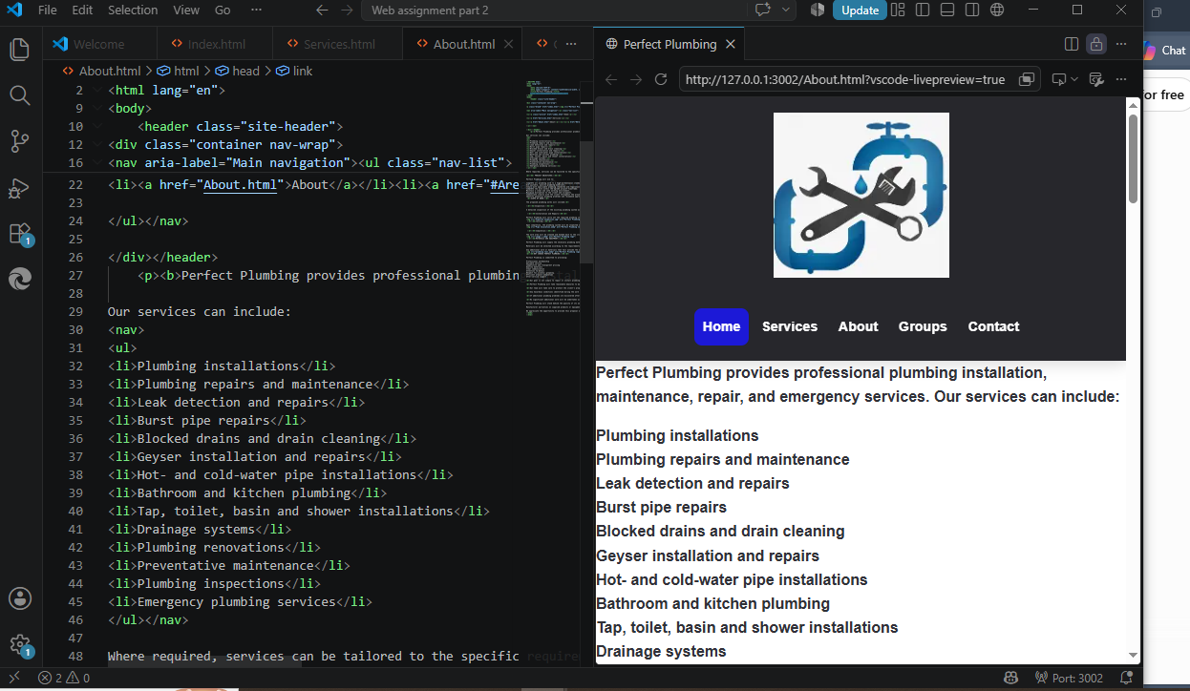
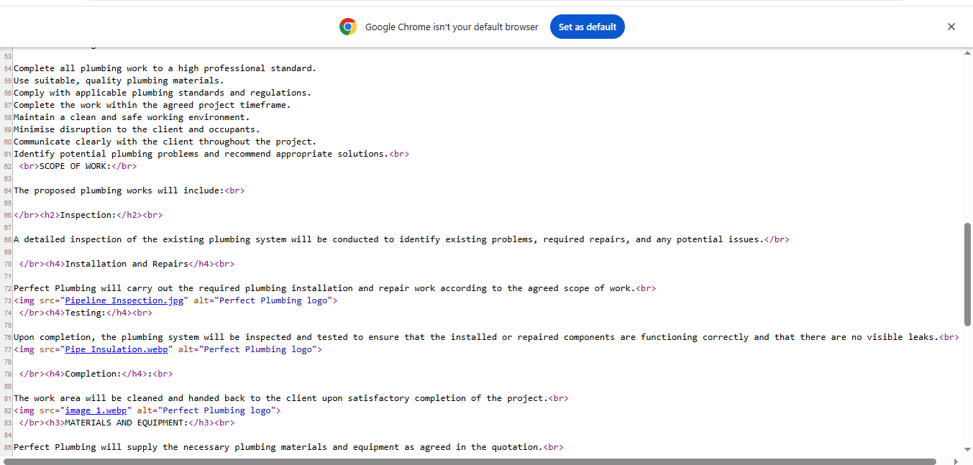
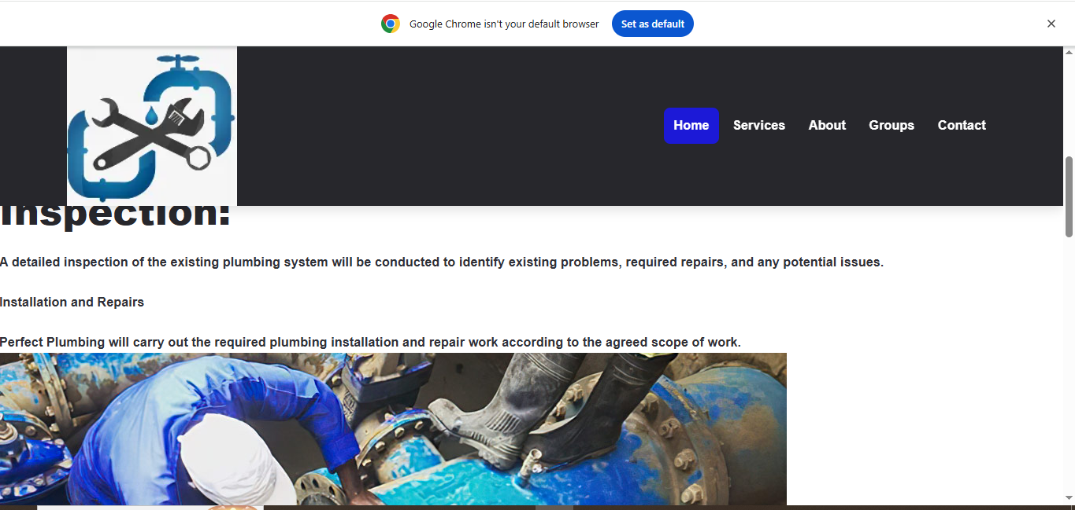
These were the results of a couple of days’ worth of coding it took awhile but things turnout ok using the image src tag I was able to put these pictures in and keep the website functional.
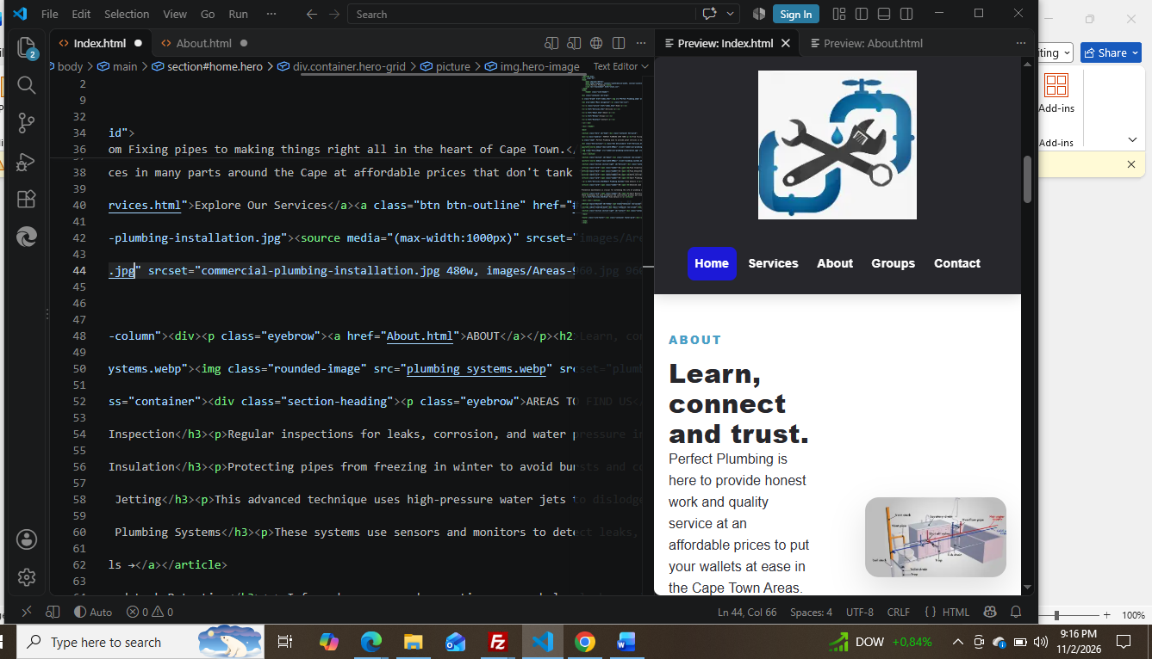
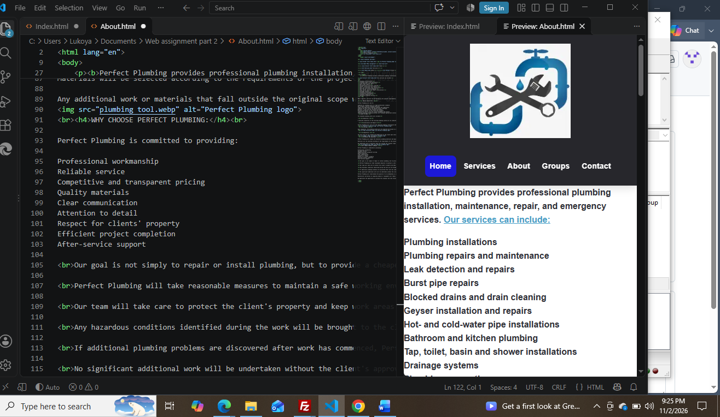
These image above show how I made the links between most of my site like the word About taking the user to the About Tab and services to the services tab the words in blue are hyperlinks keywords used to send users.
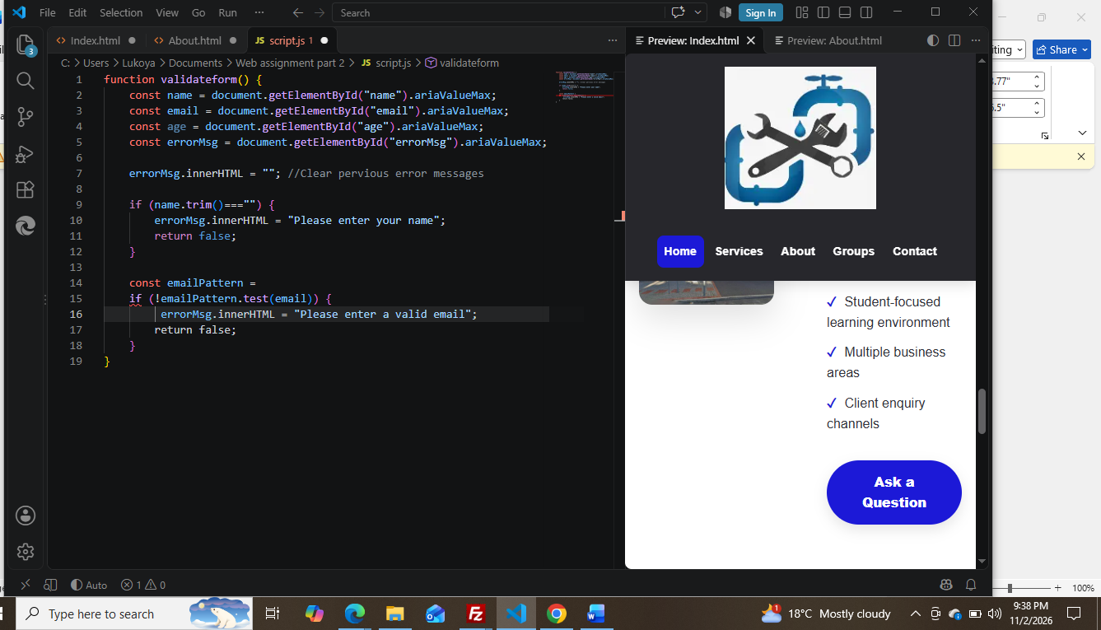
Here is the script for the I used to help with enquiries and questions.
References:
(Mr Pipey, Residental Piping systems residential-plumbing-systems-materials-tools-techniques from New Construction found at:< Plumbing: A Complete Guide to Modern Techniques and Practices>accessed 16/09/2026).
( Bendai, Common Plumbing Processes Explained from [scribd] found at:< Common Plumbing Processes Explained | PDF | Plumbing | Solder> accessed 16/09/2026).

